**Lesson05 Angular form control and form group**

**Notes:-**

**1-When Working with reactive forms we see the following:-**

**A-When working with reactive forms we create instances of Form Control and Form Group classes to create a form model.**

**B-To bind an HTML <form> tag in the template to the From Group instance in the component class, we use form Group directive**

**C-To bind an HTML <input> element in the template to the Form Control instance in the component class, we use form Control Name directive**

**D-form Group**and **form Control Name**directives are provided by the **Reactive Forms Module.**

**E-Both Form Control and Form Group classes inherit from Abstract Control base class.**

**F-The Abstract Control class has properties that help us track both Form Control and Form Group value and state.**

**G-The following are some of the useful properties provided by the Abstract Control class**

**1-value**

**2-errors**

**3-valid**

**4-invalid**

**5-dirty**

**6-pristine**

**7-touched**

**8-untouched**

**H-Form Control keeps the state of the individual element that associated with the Form Group that keeps the state of all the Form Controls**

**When we apply the event submit**

**onSubmit(): void {console.log(this.employeeForm);}**

**We see that the console in Developer Tools the properties**

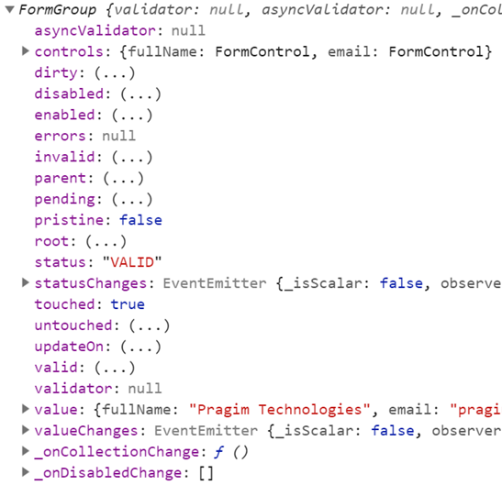

To Access the Controls in the Form Group we apply the following

onSubmit(): void {

//we can get the elements by the following 2 commands

console.log(this.employeeForm.controls.FullName.value);

console.log(this.employeeForm.get("Email").value);}

**<form class="form-horizontal" [formGroup]="employeeForm" (ngSubmit)="onSubmit()" >**

**<div class="panel panel-primary">**

**<div class="panel-heading"><h3 class="panel-title">Create Employee</h3></div>**

**<div class="panel-body">**

**<div class="form-group">**

**<label class="col-sm-2 control-label" for="fullName">Full Name</label>**

**<div class="col-sm-8"><input id="fullName" type="text" class="form-control" formControlName="FullName" /></div></div>**

**<div class="form-group">**

**<label class="col-sm-2 control-label" for="email">Email</label>**

**<div class="col-sm-8">**

**<input id="email" type="text" class="form-control" formControlName="Email" />**

**</div></div></div>**

**<div class="panel-footer">**

**<button class="btn btn-primary" type="submit">Save</button></div></div>**

**</form>**

**<table border="1">**

**<tr><th style="padding: 10px">FormGroup</th>**

**<th style="padding: 10px">FormControl (fullName)</th></tr>**

**<tr><td style="padding: 10px">**

**touched : {{ employeeForm.touched }}**

**<br/> dirty : {{ employeeForm.dirty }}**

**<br/> valid : {{ employeeForm.valid }}**

**<br/> Form Values : {{employeeForm.value | json}}</td>**

**<td style="padding: 10px">**

**touched : {{ employeeForm.get('FullName').touched }}**

**<br/> dirty : {{ employeeForm.get('FullName').dirty }}**

**<br/> valid : {{ employeeForm.get('FullName').valid }}**

**<br/> FullName Value : {{employeeForm.get('FullName').value}}</td></tr>**

**</table>**

**There are some validator of the Form Group and Form Validators**

**1-setValidators()**

**2-clearValidators()**

**3-updateValueAndValidity()**

**4-setValue()**

**5-patchValue()**

**6-Reset()**

**Example:-**

**This the Full Example of Applying Reactive Forms**

**1-In the employee-reactForm.html we apply the following**

<form class="form-horizontal" [formGroup]="empForm" (ngSubmit)="onSubmit()" >

<div class="panel panel-primary">

<div class="panel-heading">

<h3 class="panel-title">Create Employee</h3>

</div>

<div class="panel-body">

<div class="form-group">

<label class="col-sm-2 control-label" for="fullName">Full Name</label>

<div class="col-sm-8">

<input id="fullName" type="text" class="form-control" formControlName="FullName" /></div></div>

<div class="form-group">

<label class="col-sm-2 control-label" for="email">Email</label>

<div class="col-sm-8">

<input id="email" type="text" class="form-control" formControlName="Email" />

</div></div></div>

<div class="panel-footer">

<button class="btn btn-primary" type="submit">Save</button></div></div></form>

<table>

<tr><th style="padding: 10px">FormGroup</th>

<th style="padding: 10px">FormControl (fullName)</th></tr>

<tr><td style="padding: 10px">

Form Touched : {{empForm.touched}}<br />

Dirty : {{empForm.dirty}}<br />

valid : {{empForm.valid}}<br />

FormValues : {{empForm.value | json}}</td>

<td style="padding: 10px">

Form Touched : {{empForm.controls.FullName.touched}}<br/>

Dirty : {{empForm.controls.FullName.dirty}}<br/>

valid : {{empForm.controls.FullName.valid}}<br/>

Form Touched : {{empForm.controls.FullName.value}} {{empForm.get("FullName").value}}

</td></tr></table>

**2-In the employee-reactForm.ts we apply the following**

import { Component, OnInit } from '@angular/core';

// Import FormGroup and FormControl classes

import { FormGroup, FormControl } from '@angular/forms';

import { ReactiveFormsModule } from '@angular/forms';

@Component({

selector: 'app-employee-react-comp',

templateUrl: './employee-react-comp.component.html',

styleUrls: ['./employee-react-comp.component.css']})

export class EmployeeReactCompComponent implements OnInit {

//define variable of type Form Group named matched the Form Group inhtml

empForm:FormGroup;

constructor() { }

ngOnInit() {

this.empForm = new FormGroup({

FullName : new FormControl(),

Email : new FormControl()

});}

onSubmit(): void {

debugger;

console.log(this.empForm.value);

}}